Title: The Culture Iceberg
Language: English
CEFR Level: B1/B2/C1
Author: VitBox team

Descriptor:
Mode of communication / Activity, strategy or competence:  Speaking/ writing | Scale:  Building on pluricultural repertoire
Descriptor:
B1 :
Can explain in simple terms how their own values and behaviours influence their views of other people’s values and behaviours.
Can discuss in simple terms the way in which things that may look “strange” to them in another sociocultural context may well be “normal” for the other people concerned.
B2 :
Can identify and reflect on similarities and differences in culturally determined behavioural patterns (e.g. gestures and speech volume or, for sign languages, sign size) and discuss their significance in order to negotiate mutual understanding.
C1 :
Can sensitively explain the background to and interpret and discuss aspects of cultural values and practices drawing on intercultural encounters, reading, film, etc.

Introduction to task
Goals of the activity:
Talking about cultural practices. Practicing how to talk about cultural values and practices. Learning how to promote understanding.

Introducing the activity in the classroom:
Tell students about how culture is like an iceberg. Explain to them that only some cultural aspects are visible and that those that are not, are more numerous and influence on the ones we see. Have them look at the image in the activity above:
- Can they think of hidden aspects that are very relevant for their community?
- Is any of these aspects more relevant for you personally?
- How do you think these hidden aspects influence the most obvious ones (holidays, food, etc)?
Description of the main activity:
This activity can be carried out in blended learning courses as an online activity or in traditional courses as a classroom activity. As an online activity, students can share ideas by using online collaborative tools such as google docs, padlets, etherpads, etc or through videoconferencing.
Ask students to have a look at the iceberg and identify and search for any vocabulary they don’t know.

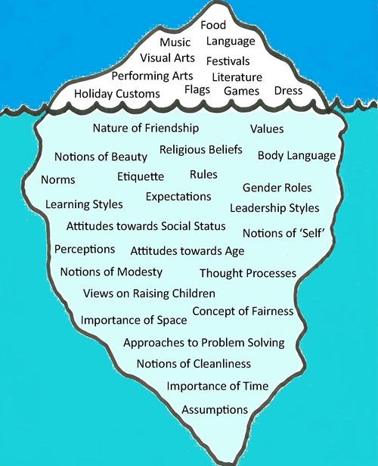
Image : Creative Commons License

Put students into groups.
- Have students in each group choose two of the hidden aspects, why have they chosen these two aspects?
- How do these two aspects influence the image a certain culture or community projects?
- Which sort of misunderstandings could arise regarding these aspects if they were raised in a conversation with people from different cultures.

Peer feedback – class discussion
Have each group share their answers with the rest of the groups
- Can miscommunication be improved if these “hidden” aspect were to be made more visible?
- Which of the aspects mentioned do you think could be more problematic in your context?

Assessment
Fill in the following table, or have their peers fill it in. The success in the completion of the task is determined by the number of questions answered affirmatively.
Yes | No

Did the students talk about the different notions illustrated in the image and discuss their meaning?

Did the students discuss about how these cultural aspects are not always visible?

Did they engage in a conversation about two of the aspects? (did they talk about why they chose them amongst the rest?
Did they talk about how hidden aspects being more visible can influence our perception of the culture?
Did they identify which of these aspects could be more problematic and why?

